Name: Mohamed Ramadan Mohamed Rashad

B.N: 711

Sec: 32

Date: 7/6/2021

______________________________________________________

Topic: Database System

Application Brief:

A **database** is an organized collection of [data](https://en.wikipedia.org/wiki/Data_(computing)), generally stored and accessed electronically from a computer system. Where databases are more complex they are often developed using formal [design and modeling](https://en.wikipedia.org/wiki/Database#Design_and_modeling) techniques.

The [database management system](https://en.wikipedia.org/wiki/Database#Database_management_system) (DBMS) is the [software](https://en.wikipedia.org/wiki/Software) that interacts with [end users](https://en.wikipedia.org/wiki/End_user), applications, and the database itself to capture and analyze the data. The DBMS software additionally encompasses the core facilities provided to administer the database. The sum total of the database, the DBMS and the associated applications can be referred to as a "database system". Often the term "database" is also used to loosely refer to any of the DBMS, the database system or an application associated with the database.

Computer scientists may classify database-management systems according to the [database models](https://en.wikipedia.org/wiki/Database_model) that they support. [Relational databases](https://en.wikipedia.org/wiki/Relational_database) became dominant in the 1980s. These model data as [rows](https://en.wikipedia.org/wiki/Row_(database)) and [columns](https://en.wikipedia.org/wiki/Column_(database)) in a series of [tables](https://en.wikipedia.org/wiki/Table_(database)), and the vast majority use [SQL](https://en.wikipedia.org/wiki/SQL) for writing and querying data. In the 2000s, non-relational databases became popular, referred to as [NoSQL](https://en.wikipedia.org/wiki/NoSQL) because they use different [query languages](https://en.wikipedia.org/wiki/Query_language).

Databases are used to support internal operations of organizations and to underpin online interactions with customers and suppliers (see [Enterprise software](https://en.wikipedia.org/wiki/Enterprise_software)).

Databases are used to hold administrative information and more specialized data, such as engineering data or economic models. Examples include computerized [library](https://en.wikipedia.org/wiki/Library) systems, [flight reservation systems](https://en.wikipedia.org/wiki/Flight_reservation_system), computerized [parts inventory systems](https://en.wikipedia.org/wiki/Parts_inventory_system), and many [content management systems](https://en.wikipedia.org/wiki/Content_management_system) that store [websites](https://en.wikipedia.org/wiki/Website) as collections of webpages in a database.

Screenshots:

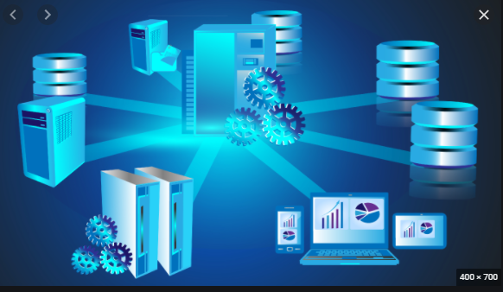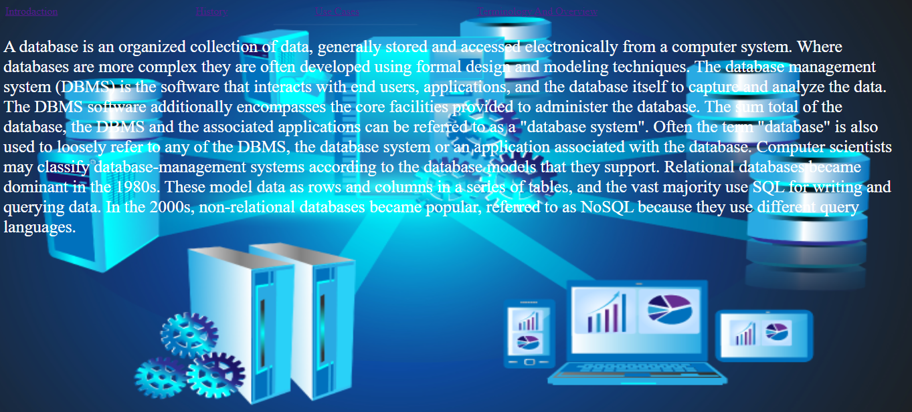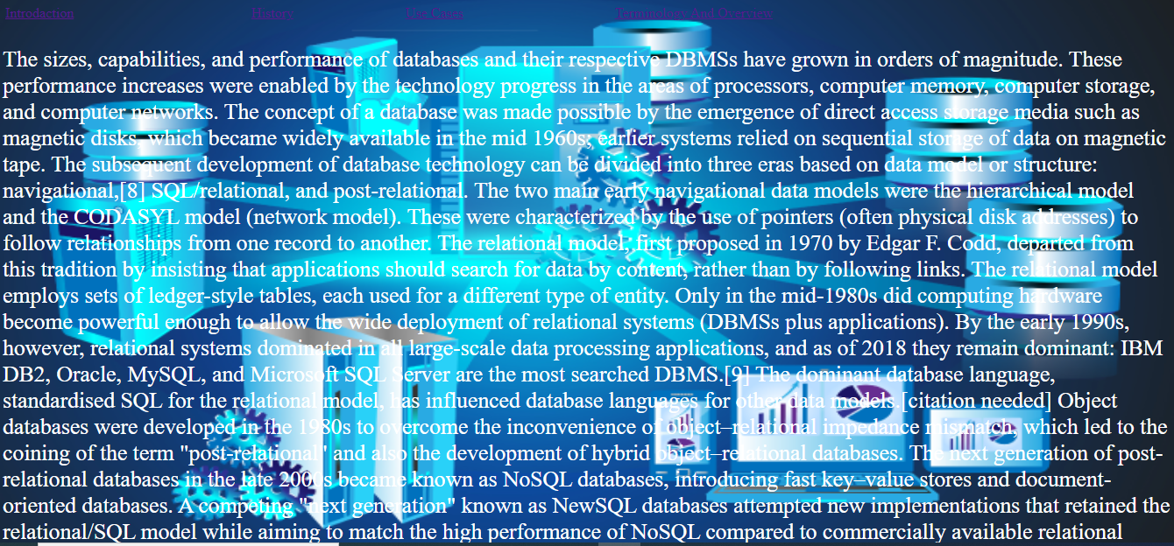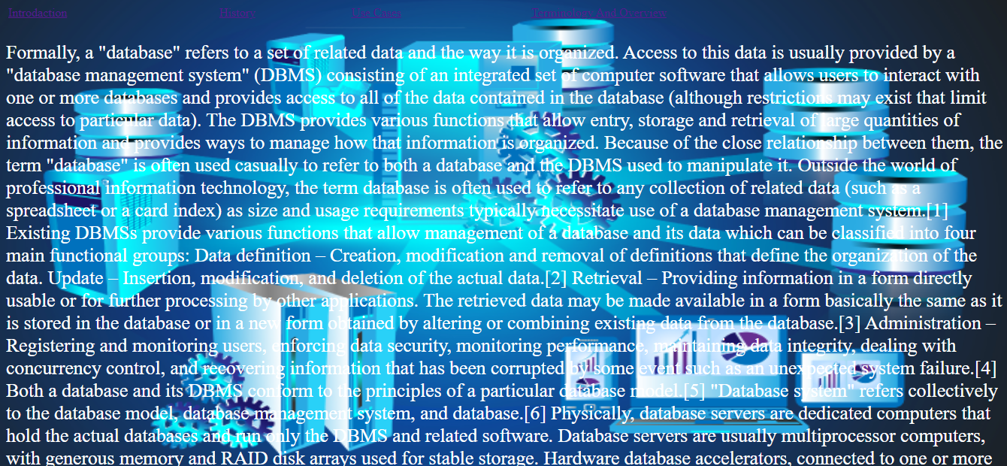

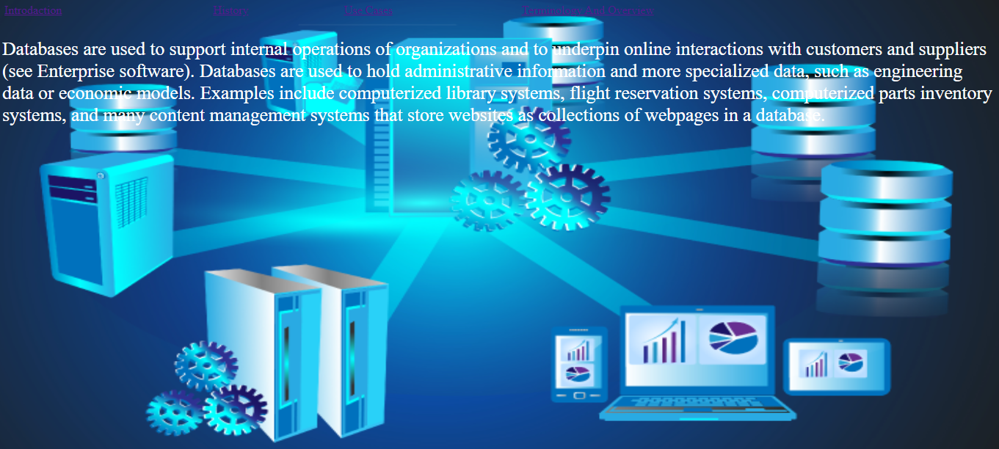

**Database System Main Page**

Links:

-introduction

-History

-Use Cases

Terminology and overview -

**Source Code:**

